“**Exploring the Dynamics of Consumer Behavior and Technological Impact: A Comparative Study of Offline and Online Shopping in the Digital Age”**

|  |  |
| --- | --- |
| S.No | Title |
| 1. | Abstract |
| 2. | Introduction |
| 3. | Literature Review |
| 4. | Objectives of the study |
| 5. | Research Methodology |
| 6. | Discussion and Analysis |
| 7. | Findings and Recommendations |
| 8. | Conclusion |
| 9. | Bibliography |

**Abstract:**

The research project aims to analyze and study the difference in consumer behavior in case of online shopping environments and offline shopping environments.

The two main objectives of the study are:

(i) Understanding consumer behavior, as it is a continuously evolving phenomenon.

(ii) Technological impact on the preferences and tastes of customers as the technological developments expose them to a vast multitude of information very easily and also the ease of purchasing and personalized recommendations can be an icing on the cake.

The study is based on both secondary sources as well as primary sources. For the primary source we have conducted a survey on the students of Punjab Engineering College to find out their preferences and interests in case of shopping.

The study finds out that the consumer behavior depends on many factors in case of both online as well as offline shopping some of them being, ease of purchase and return, lifestyle habits, social media influence and demographics. Even when the world of today is more inclined towards online shopping, the brick and mortar stores still find their place in the market.

The study finally concludes that the latest tendencies of consumer behavior in the digital age are looking to reflect dynamism among evolving preferences, technological advancements, and changing retail dynamics. While online retail gains momentum, offline stores remain relevant, particularly for experiences that benefit from physical interaction.

Some limitations of the study can be:

(i) The sample population is limited to only one geographical area leading to the geographical bias in the opinions.

(ii) The sample population is also limited to only one age group i-e- 18-20 years.

(iii) The study does not analyze the population’s preferences in a quantified manner.

**Introduction:**

The research intends to examine consumer conduct in a web shopping environment and compare consumer preferences and choices on the internet with those of brick-and-mortar stores that are offline or physical stores. We also intend to determine the effect of online shopping on the real economy through this project. This research paper seeks to comprehensively analyze online shopping versus offline shopping dynamics highlighting the benefits, drawbacks and implications for customers and distributors.

At first, companies started experimenting with selling goods online, initially via simple websites, then dedicated e-commerce platforms. Some of the reasons why people have come to like it include convenience, wide selection as well as often you find it cheap compared to traditional retailers.

In the development of consumer behavior in e-commerce and traditional shopping, technology advances, societal shifts, and personal preferences have played a crucial role. Here is a brief summary:

1. **Early Years (1990s):** Online shopping began in the 1990s with the establishment of the World Wide Web. This was followed by consumers who were more comfortable with offline transactions.

2. **Late 1990s to Early 2000s:** E-commerce started picking up momentum due to an improved Internet infrastructure and better security regarding payment systems.

3. **Mid-2000s to Late 2000s:** Amazon’s rise among other e-commerce giants led to an increased shift towards online buying.

4. **Early 2010s:** The advent of smartphones and mobile apps transformed customer behavior. Mobile commerce (m-commerce) boomed as people embraced buying things while they were moving.

5. **Mid-2010s to Present:** With omnichannel retailing, there is a blurring of lines between online and offline purchase behaviors.

6. **Current Trends (2020s):** Personalization, social commerce, and sustainability are shaping consumer behavior. AI-driven recommendations, influencer marketing, and eco-friendly initiatives are influencing purchasing decisions both online and offline.

Various factors are the drivers of consumer behavior that are continuously changing.

* **Technological Advancements:** The shopping experience has continued to change due to innovations such as AI, AR/VR and blockchain thereby influencing consumer interactions with brands and purchase decisions they make.
* **Social and Cultural Shifts:** Consumer preferences are influenced by changing demographics, lifestyles, and cultural norms.
* **Economic Factors:** Spending patterns can be affected by economic downturns, income levels, and consumer confidence. Consumers may turn to value-focused purchases and discounts when there is an economic slump leading to effects on both online and offline retail sectors.
* **Regulatory Changes:** Consumer behavior can be impacted based on legislation regarding data privacy, online security or consumer rights.
* **Pandemic Effects:** The COVID-19 pandemic sped up digital transformation as well as changed the way consumers behave. Lockdowns together with social distancing guidelines led to increased internet buying resulting in permanent changes in shopping habits and preferences.

On the other hand, in store shopping remains vital to retailers as it allows for contact and a chance to experience products immediately and have person-to-person interactions which may not be feasible through online platforms. Through offline retail stores, customers can touch things directly, receive help from knowledgeable employees, and talk with friends or family members while they are making purchases.

By way of an extensive review of existing literature, empirical studies as well as case examples this study will attempt to throw more light on online-offline relationships within the complex context of such issues touching upon their respective roles, challenges, and opportunities in the contemporary retail environment.

**Literature Review:**

**Need of the Study:**

In the current times of continuous and fast digital transformation, understanding consumer behavior in digital environments has become the need of the hour. The digital landscape has reshaped how consumers’ engagement and interaction with products and services, almost erasing the lines between online and offline experiences. Furthermore, offline actions influence online activities, just as online actions impact the world beyond the internet. Researchers and practitioners are keen to delve into various facets of digital consumer behavior from the lens of behavioral science.

Some of the most important objectives for studying are outlined below:

Technological growth and changes, shifts in values, and changes in ways of retailing have led to rapid change in consumer’s behavior. Below mentioned are a few patterns:

In the digital era, consumers have a multitude of information available to them, enabling aware decision-making. They have the capability to research any information about products, compare prices and analyze reviews before deciding on a purchase.

* Increase in Online Shopping: The ease of online shopping has resulted in a steep increase in e-commerce. Consumers are now more interested in shopping online, with the rise in popularity of mobile devices.
* Impact of Social Media: Social media channels greatly influence consumer behavior. Influencer marketing, content created by users, and social recommendations all play a role in affecting buying decisions.
* Mobile devices play an important role in shaping consumer behavior. The importance of mobile shopping apps, personalized notifications, and smooth experiences has increased significantly and has led to impulse shopping and also continuously evolving consumer behavior.
* Personalization and customization: Consumers want personalized experiences. Brands that provide personalized suggestions and tailored items have a competitive advantage.
* Ethical and Sustainable Practices: Brands focusing on sustainability and transparency successfully attract socially conscious and aware consumers.
* Shopping locally and eco-consciously: Consumers are interested in finding the most affordable options.
* Concerns about data privacy are continuously increasing as instances of data breaches and privacy violations are constantly being heard of, leading consumers to worry about divulging personal information. Brands need to tackle privacy issues in order to establish trust.
* Augmented Reality (AR) and Virtual Reality (VR) improve consumers’ experience by enabling letting customers see products in a virtual setting before buying them.

The field of consumer behavior evolves all the time and these trends will continue to change as technology changes and consumer preferences and interests shift.

Consumer behavior keeps evolving, trends will keep growing with changes in technology and consumer preferences.

* Inspecting Influences: analyzing psychological and social influences on customer behavior in the digital environment.
* The Impact Of Digital Marketing Strategies On Consumers’ Decision Making.
* Assessing How Different Social Media Platforms Influence Customers Such As Comparing Youtube And Instagram.
* Considering The Ethical Implications Regarding Data Privacy.
* Creative Discoveries: Finding new ways to apply behavioral insights in digital marketing and influencer campaigns on social media.

Furthermore, to delve deeper into the topic of consumer behavior analysis in case of online shopping and offline shopping, below is given the **review of** **10 research papers.**

* **How Information Technology (IT) is shaping consumer behavior in the digital age: A systematic review and future research directions**

Modern business success is contingent on the realization and understanding of customer behavior trends in the context of IT. In spite of the strides made in studying consumer behavior, there is a need to use technology as a vehicle for exploration between information technology and consumer behavior hence giving rise to new insights that boost the performance of organizations.

This essay delves into how IT intersects with customer behavior by using systematic literature review (SLR) method based on Prism for Systematic Reviews and Meta-Analyses (PRISMA) 2020 guidelines indexed under the SSCI & SCIE categories from Web of Science. A total of 40 eligible articles were selected from the PRISMA approach. The four main themes identified by researchers included: technology diffusion, consumer behaviors, IT and consumer behaviors, and impact of IT on consumer behaviors.

The key findings of the study include:

* Diffusion of Technology: IT has been found to be pervasive throughout a wide range of industries. Businesses must understand and adapt to these technological changes in order to remain competitive.
* Consumer Behavior: Disruption of consumer behavior by IT comes with its own disruptive measures. Traditional marketing strategies are influenced by consumers’ engagement with corporate brands through digital channels. It is necessary for businesses to comprehend these shifts.
* Impact of IT on Consumer Behavior: IT affects how individuals make purchases, interact with products, and initiatives made by organizations that deal with brand awareness. Companies have to align their strategies along these digital dynamics.
* Research Agenda: Identify research gaps and future directions in research. This highlights the need for more studies into the growing relationship between information technology and consumer behavior.

Limitations

* Time Limitation: A review is conducted within a certain period until a particular date. Any new research or emerging trends may not be captured by the results.
* Geographic Area: Some articles can concentrate on one region or country while ignoring other cultural types of perspectives.
* **The Impact of E-commerce on Consumer Behavior in Vietnam :**

In the contemporary landscape, the proliferation of the internet and the advent of Innovation 4.0 have rendered online shopping a pressing concern. The rapid growth of e-commerce has transformed the way products and brands engage with customers, profoundly impacting consumer behavior. This thesis investigates the impact of e-commerce on consumer behavior in Vietnam.

Key points from the study:

* **Factors Shaping Consumer Behavior:** The research delves into societal factors, psychology, personal aspects, and cultural influences on virtual shopping behavior.
* **E-commerce Infrastructure:** It provides an extensive overview of e-commerce infrastructure, its current state, types, and benefits.
* **Multichannel Shopping:** The study explores how e-commerce affects traditional brick-and-mortar retail, emphasizing “multichannel” shopping where consumers seamlessly transition between offline and online channels.
* **Consumer Attitudes and Preferences:** A survey conducted with 100 participants reveals that convenience, price, discounts, and special offers significantly influence purchasing decisions. Perceived risk negatively impacts decisions, but pricing plays a crucial role.

Here are two **case studies** of successful e-commerce implementation in Vietnam:

1. Shopee Vietnam: Shopee is a popular e-commerce platform in Vietnam that has experienced significant growth in recent years.Shopee’s success can be attributed to several factors:

* **User-Friendly Interface:** Shopee provides an intuitive and easy-to-navigate platform for both buyers and sellers.
* **Mobile-First Approach:** Shopee optimized its app for mobile devices, catering to the high mobile penetration in Vietnam.
* **Marketing Strategies:** Shopee runs frequent promotions, discounts, and special campaigns to attract and retain users.
* **Strong Logistics Network:** Efficient delivery and reliable logistics contribute to customer satisfaction.
* **Multichannel Shopping:** Shopee seamlessly integrates online and offline channels, allowing consumers to switch between them.

Shopee’s success story serves as an inspiration for other e-commerce businesses in Vietnam.

1. Lazada Vietnam: Lazada, another major e-commerce player, has established a strong presence in Vietnam.Key factors contributing to Lazada’s success:

* **Wide Product Range:** Lazada offers a diverse range of products, attracting a broad customer base.
* **Effective Marketing:** Lazada invests in marketing campaigns, including partnerships with influencers and celebrities.
* **Customer Support:** Lazada provides responsive customer service, addressing user queries promptly.
* **Secure Payment Options:** Lazada ensures secure payment gateways for hassle-free transactions.`
* **Localized Approach:** Lazada tailors its offerings to Vietnamese preferences and cultural nuances.
* Lazada’s case study highlights the importance of understanding local context and adapting strategies accordingly.

Both Shopee and Lazada demonstrate how strategic planning, user-centric design, and effective marketing contribute to successful e-commerce implementation in Vietnam.

* **Shopping in the digital world: How augmented reality mobile applications trigger customer engagement**

It is the maturation and rise in popularity of AR technology that have brought forth an array of AR-related applications. Incorporating AR into commerce allows marketers to increase brand attraction and popularity, which affects how customers engage with the product or service effort. Therefore, more brand owners and retailers are investing in the AR commercial services industry. The research model identifies the salient attributes of AR technology that induce a flow in its usage and enhance satisfaction with AR services, fostering customer engagement intentions. Data from 212 valid online questionnaires were analyzed using partial least squares structural equation modeling.

The findings indicate that both flow experience and user satisfaction play crucial roles in driving customer engagement with AR commercial services. Interactivity, vividness, and novelty are identified as critical factors affecting users’ flow experience and satisfaction. The implications of these findings are discussed.

The research identifies three key characteristics of AR technologies: interactivity, vividness, and novelty. These attributes play a crucial role in shaping the engagement of customers within AR commerce applications.

* Interactivity: AR technologies allow users to actively engage with digital content in their physical environment. This interaction creates a dynamic experience, enhancing user satisfaction.
* Vividness: The richness and realism of AR content contribute to user immersion. Vivid visuals and lifelike elements enhance the overall experience.
* Novelty: Novelty refers to the freshness and uniqueness of AR experiences. Users are drawn to novel interactions, which can lead to increased engagement.

The study acknowledges that users’ engagement states fluctuate as they interact with AR functionalities. However, despite the significance of these characteristics, there is a lack of organized knowledge regarding their relative importance. This gap in the literature necessitates a deeper exploration.

The study aims to answer several critical questions:

* Can AR characteristics foster an improved mental state of flow among customers after interacting with an AR commerce app?
* Which specific AR characteristics significantly influence users’ flow experience and satisfaction levels?
* What mechanisms underlie these effects?
* If users fail to experience flow or attain satisfaction, could this lead to heightened engagement with the AR commerce app?

In summary, AR technology holds significant potential for enhancing customer engagement in commercial contexts, and understanding its key attributes can inform effective marketing strategies and brand interactions.

**E-Commerce expansion:** Global business-to-consumer sales are expected to rise, contributing to the e-commerce industry's notable expansion. It is anticipated that e-commerce expenditure would surpass North America in the Asia-Pacific area in particular.

**Research Gap**: Because the Asia-Pacific region has different market dynamics and cultural norms from Western nations, there is a dearth of information in studies on the adoption of online shopping that pertains to this region.

**Consumer Adoption:** The simplicity of use, especially when it comes to payment procedures, and the availability of product information are factors that impact consumers' adoption of online shopping. Products pertaining to entertainment are more easily accepted for online shopping.

**Product Type Impact:** Product type has a big impact on how many people shop online. People prefer to buy groceries and expensive items like jewelry in person, but they also prefer to buy entertainment-related products online.

This review emphasizes how crucial it is to comprehend how consumer preferences are influenced by product type and how regional variations in e-commerce adoption occur.

Businesses engaged in e-commerce face a number of difficulties when navigating the digital environment. Let's examine a few of these challenges and possible fixes:

**Choosing the Correct Products:**

Making a lasting impression in the cutthroat e-commerce market requires choosing the correct products.

From the outset, take into account market demand and marketing strategy.

To comprehend the demands and tastes of consumers, conduct in-depth market research.

Keep abreast of market developments to spot goods that satisfy consumer demand.

Choosing Your Target Audience: Although e-commerce companies can reach a worldwide audience, it may be difficult to identify your target clientele.

Utilize market research to determine the demographic traits that prospective customers have in common.

To better target marketing messaging and customer acquisition tactics, create buyer personas.

**How to Position Your Product:**

Create a concise value proposition that explains to your target market the benefits and significance of your product.

Recognize how your product stacks up against the competition's current offers.

Verify concepts and hooks that result in product sales.

**Budget Allocation for Digital Marketing:**

Allocate funds for digital marketing that works.

Sort your audience-relevant platforms (such social media and search engine marketing) into priority lists.

Evaluate performance on a regular basis and modify budgets as necessary.

**Creating Social Proof:**

Displaying gratifying client endorsements, testimonies, and social media references will help you establish credibility.

Potential customers are encouraged to make a purchase by social proof, which increases trust.

**Creating an Online Store That Is Easy to Use:**

Make sure the navigation on your website is simple, responsive, and straightforward.

Make product pages more efficient.E-Commerce Growth: The e-commerce industry has seen significant growth, with a forecasted increase in global business-to-consumer sales. The Asia-Pacific region, particularly, is expected to surpass North America in e-commerce spending.

**Research Gap:** Studies on online shopping adoption have predominantly focused on data from Western countries, leaving a gap in literature regarding the Asia-Pacific region, which has distinct cultural and market dynamics.

**Consumer Adoption**: Factors influencing consumer adoption of online shopping include the availability of product information and ease of use, particularly in payment processes. Entertainment-related products are more readily accepted for online purchasing.

**Product Type Impact:** The type of product significantly affects online shopping adoption, with a preference for purchasing entertainment-related products online, while groceries and high-value items like jewelry are preferred to be bought in retail stores due to quality assurance concerns.

This review highlights the importance of understanding regional differences in e-commerce adoption and the impact of product type on consumer preferences.

* **E-commerce businesses encounter several challenges as they navigate the digital landscape.**

Let’s explore some of these hurdles and potential solutions:

**Choosing the Right Products:**

* In the competitive e-commerce space, selecting the right products is crucial for standing out.
* Consider market demand and marketing strategy from the outset.
* Conduct thorough market research to understand consumer needs and preferences.
* Stay updated on market trends to identify products that meet customer demand.

**Identifying Your Target Audience:**

* E-commerce businesses can reach a global audience, but this can make it challenging to pinpoint your ideal customers.
* Use market research to identify common demographic factors among potential buyers.
* Create buyer personas to tailor marketing messages and customer acquisition strategies.

**Positioning Your Product:**

* Develop a clear value proposition that communicates your product’s value and relevance to your target audience.
* Understand how your product compares to existing offerings in the market.
* Validate hooks and ideas that lead to product sales.

**Allocating Digital Marketing Budgets:**

* Effective digital marketing requires budget allocation.
* Prioritize channels that resonate with your audience (e.g., social media, search engine marketing).
* Regularly assess performance and adjust budgets accordingly.

**Building Social Proof:**

* Establish credibility by showcasing positive customer reviews, testimonials, and social media mentions.
* Social proof builds trust and encourages potential buyers to make a purchase.

**Designing a User-Friendly Online Store:**

* Ensure your website is intuitive, responsive, and easy to navigate.
* Optimize product pages, checkout processes, and mobile experiences.
* A seamless user experience enhances customer satisfaction.

**Increasing Conversions:**

* Focus on improving conversion rates (i.e., turning visitors into buyers).
* Optimize product descriptions, images, and calls-to-action.
* Implement A/B testing to identify effective strategies.

**Providing Good Customer Service:**

* Promptly address customer inquiries, complaints, and returns.
* Excellent customer service fosters loyalty and encourages repeat business.

**Managing Logistics:**

* Efficiently handle inventory management, order fulfillment, and shipping.
* Collaborate with reliable logistics partners to ensure timely deliveries.

**Maintaining E-commerce Site Security:**

* Protect customer data, prevent security breaches, and secure payment gateways.
* Regularly update software and monitor for vulnerabilities.
* Build trust by prioritizing security and privacy.
* Remember, each challenge presents an opportunity for growth and improvement. By addressing these obstacles strategically, e-commerce businesses can thrive in the digital marketplace.
* **Shopping in the digital world: How augmented reality mobile applications trigger customer engagement**

Knowledge gaps between the customer and the brand in relation to shopping in AR may be another future research point. Since AR is a new technology, not many customers are aware of what can precisely be done through AR and might need to be informed by the brand.

This elaborates on how customers come to develop interest and engagement with brands under the help of AR shopping experiences. Herein below is an elaboration of highlights alongside a detailed discussion.

**1. Importance of customer engagement in Shopping in RR:**

Having been the breeding ground for brand engagement for years, traditional lines of tools—such json websites and social media—now give way to AR technology to make these avenues its own, expanding what is possible and opening up new frontiers of unique and interactive shopping experiences. AR technology can be useful for AR shopping apps by attracting customers to spend more time on the product discovery, which will finally turn into more sales and brand stickiness.

**2. Impact of AR features on user experience:**

The research defined three key characteristics of AR that had to be given, required to enrich the user experience: interactivity, vividness, and novelty. This is in a manner that the customers are given an opportunity to touch and be able to manipulate the virtual products in reality. For example, the functionality of virtual try-on clothing and overlay of furniture in a room can be made playful and involving. Vividness is the quality of AR experience in which the products have a realistic, visually appealing representation that evokes a sense of being immersed, and in the process, aiding them in evaluating the product before they make a purchase. Novelty has been defined as uniqueness in an AR experience.

**3. Flow Theory and User Satisfaction**

In this study, flow theory is used to clarify how AR features can contribute to a pleasant user experience.

Flow is a mental state where people have complete absorption and focused enjoyment in their activity. AR features that are vivid, novel, and highly interactive could facilitate a state of flow whereby the user becomes fully absorbed into the AR shopping experience and may lose track of time. And this eventually results in the stream of user satisfaction and further propels the brand engagement.

**4. Knowledge gap and future research**

Avenues for the furtherance of this study would be to acknowledge the knowledge gap between the customers and the brand, with respect to shopping in AR. Since it is fairly new technology, most customers may not be aware of the features that come with AR and would have to be guided by the brand.

* **What is the behavior of people for adoption of online shopping instead of the conventional one?**

The adoption of online shopping by people over traditional mode consists of complex interplay factors influencing behavior; here are the details of some key behavioral patterns:

**Perceived Benefits:**

**Convenience:** This is the main motivator. Doing online shopping will save time and effort that could have been used in visiting the shops. You can do it from anywhere at any time and avoid the crowdedness of people.

**Selection & Variety:** An online retailer, more often than not, gives a wider choice of products compared to his physical store colleague and, therefore, allows finding a specific thing within niche items or a preferred brand name.

**Price Comparison & Deals:** People derive such utility from the utility because they can compare prices of several online retailers and be in a position to get good deals, like coupons or discounts.

**Transparency and Information:** Most of the time, the online stores provide all needed information through elaborate descriptions of products, reviews, and ratings.

**Reduced Barriers:**

**Technology Adoption:**

As people become more comfortable using technology and the internet, online shopping becomes less intimidating.

**Improved Security:** Enhanced security measures and buyer protection programs on online platforms address concerns about financial security.

**Mobile Shopping:** The new rise of mobile shopping with very user-friendly and easy-to-shop applications.

**Shifting Demographics:**

**Younger Generations:** We can probably label the technology early adopters and likely the people who grew up with the technology, feeling more comfortable about doing business online.

**Overcoming Concerns:**

**Trust & Security:** While security has improved, some people might still have reservations about online transactions.

**Product Experience:** The inability to touch or even try on their products, in certain cases, definitely limits the product experience, especially in categories such as apparel.

**Delivery & Returns:** Sometimes, this brings in an issue with the delivery, so is the concern of a return policy and possible shipping cost. The improvement in technology would continue to overcome the concerns and make online shopping respectively easy, secure, and convenient.

**Pay-on-Delivery (POD):**

With POD coming forth as a critically important factor in a market where trust for online transactions might still be evolving, the paper had actually investigated how customers' confidence and the result in satisfaction with their online shopping are impacted through the chance to pay for the product on delivery.

**Methodology and Key Findings:**

The questionnaire was applied diligently to the shoppers. For the applied conceptual framework of the present analysis, data were collected through a self-administered, structured questionnaire. Confirmatory factor analysis (CFA) and Structural Equation Modeling (SEM) were then carried out as a means of analyzing the data collected in the attempt to model the relationships existing between the various measured variables.

**Social Media, Reverse Logistics & POD Matter:**

The three newly introduced variables—independent variables of social media, reverse logistics, POD—had very strong significant positive impacts on dependent variable customer satisfaction.

Thus, it is easily derived that the Indian online shoppers attach much value to the influence of social media, ease of return of the products, and security factors of POD.

**Implications for Online Retailers:**

The study could therefore form invaluable insight for online retailers, both those planning to venture in the Indian market and those already having operations there. From these findings, such retailers can design marketing strategies that target customers and understand the unique factors most likely to improve customers' satisfaction in such a setup.

**Leverage of social media:** Such a strong presence through social media offers online retailers a potential form of direct interaction with possible customers, showing product offers, and basically exploiting the influence of social power in chasing online sales.

**Streamlining Returns:**

Clear and convenient return policy oriented towards building trust with the customer at the time of potential online purchases.

**Offer POD:** Entertaining the customers to have the option of cash on delivery not only meets their apprehensions over online security issues but also caters to the other segment of customers who may not be so amicable toward the digital payment systems.

**Demystifying Online Shopping Adoption in India:** The Role of Social Media, Returns, and Cash on Delivery The Indian case, where the market of online shoppers burgeons faster than ever before, provides an interesting case study to understand consumer behavior.

**Social Media:** Focuses on social media and its powerful impact in the current world, primarily detailing how it influences decision-making in regard to online shopping. Social media platforms serve as a breeding ground for product reviews, brand interaction, and recommendations.

**Pay-on-Delivery (POD):** This is an important new factor in the case that online trade is still growing. The research aims to explore how the possibility of the purchase of goods delivered helps in building the confidence of the customers, which, in the nutshell, helps in gaining the satisfaction of customers while purchasing through online means.

**Methodology and Key Findings:**

These 424 online shoppers living in North Indian states participated in the present study. The proposed conceptual model was tested using self-administered and structured questionnaires for data collection.

The collected data was analyzed through the use of confirmatory factor analysis (CFA) and structural equation modeling (SEM), and this was in order to determine the measured model and the structural model between the variables.

**The findings of the study paint a compelling picture:**

**Social Media, Reverse Logistics, and POD:** All the three variables newly introduced—social media, reverse logistics, and POD—indubitably portrayed from their impacts the significant positive influence on customer satisfaction.

**UTAUT2 Constructs Not Significant:** Interestingly, of UTAUT2 well-established factors, only facilitating conditions (personal ease of use), hedonic motivation (enjoyment of technology use), and habit (automatic behavior) had no clear significant effect on predicting the online shopping behavior within this context.

**Implications for Online Retailers:**

Thus, this piece of research has quite significant implications for the online retailer who is setting out their journey or extending their business in the Indian market. Theoretically, understanding the actual factors that can determine satisfaction among customers in their own context can actually help design strategies for targeted marketing.

**Social Media Leverage:** An effective social media interaction enables the retailer to display the products to the prospective customers and could even leverage social influence to increase its online sales push. Easy returns: Trust in online purchasing grows easily understandable and easy-to-follow return policies that are convenient for the customer, and free from any ambiguities.

**"Online Shopping vs Offline Shopping: A Comparative Study" by Raja Sarkar and Dr. Sabyasachi Das:**

Online Shopping vs Offline Shopping

* This research tries to juxtapose shopping behaviors online with those in offline stores. The aim is, however, it so happens that in certain situations of products, consumers go for one choice over the other.

Factors Affecting Shopping Behavior

* **Need Recognition:** This is the first step of the consumer decision process where he recognizes the problem or need. Very common for this step in either online or offline modes.
* **Information search:** Consumers search for information on goods that could help them satisfy their demands. Comparative shopping costs less when some form of media is used, rather than the use of traditional media channels, like browsing on the internet versus browsing through books and magazines.
* **Evaluation of Alternation:** Customers are in a wide spectrum through the internet from which they can make their choices in the goods. They also read what others said, who had used them before.
* **Purchase:** While purchasing, customers either from the physical outlet or online will never find the difference in the final product; the difference will always be there only in the purchasing system.
* While buying online, a customer purchases anything with home delivery. Otherwise, he had to wait for shipping. In offline stores, a customer gets a takeaway and can easily take away the product right after purchasing.
* **Post-purchase evaluation:** if the person does not like one that is newly bought from Internet shopping, then he or she can easily return it compared to the one bought in the store because there are policies that allow such a process. Is it so, really?

Advantages of Online Shopping

* **Convenience:** Consumers can shop from anywhere at any time.
* **Variety:** Online stores can offer a wider variety of products than physical stores.
* **Consumer Reviews:** Consumers can read reviews from other consumers before they buy a product.
* **Comparison Shopping:** Consumers can easily compare prices and features of products from different stores.
* **Discounts:** Online stores often offer discounts and promotions that are not available in physical stores.

Advantages of Offline Shopping

* **Tangibility and Trialability**: Consumers can physically examine products before they buy them.
* **Shopping Experience:** Shopping in a physical store can be a fun and social experience.
* **Immediate Availability:** Consumers can take the product home with them immediately after purchase.
* **Easier Returns:** Consumers can return products to a physical store without having to deal with shipping.

**Conclusion**

The choice between online shopping and offline shopping depends on the individual consumer's needs and preferences. Online shopping is a convenient option for consumers who are looking for a wide variety of products and discounts. Offline shopping is a better option for consumers who want to physically examine products before they buy them or who are looking for a fun and social shopping experience.

The research also suggests that an omnichannel strategy, where retailers are present in both online and offline channels, is becoming increasingly popular. This allows retailers to tap into the demands of a wider range of consumers.

* **“Untact”: a new customer service strategy in the digital age**

This article explores the concept of "untact" services, a new customer service strategy emerging in the digital age. Here are the key points:

* **Background:**
  + Digital technologies are changing customer behavior and purchasing habits.
  + Customers increasingly demand convenience, speed, and customization.
  + Traditional service models with face-to-face interactions are evolving.
* **What is "Untact" Service?**
  + A service provided without face-to-face encounters between employees and customers.
  + Enabled by advanced technologies like AI, mobile apps, self-service kiosks, etc.
  + Appealing to customers who prefer to avoid interaction or value efficiency.
* **Benefits of Untact Service:**
  + **For Customers:** Convenience, time-saving, privacy, personalization.
  + **For Businesses:** Cost reduction, wider customer reach, faster service delivery.
* **Examples of Untact Services:**
  + Online shopping and mobile payments.
  + Self-service kiosks at restaurants or banks.
  + Unattended convenience stores (e.g., Amazon Go).
  + Chatbot-powered customer service.
* **Future of Untact Services:**
  + Expected to become more widespread with technological advancements.
  + Businesses need to understand customer preferences for untact vs. traditional service.
  + Companies should balance untact with human interaction for specific customer needs.
* **"How Information Technology (IT) Is Shaping Consumer Behaviour in the Digital Age: A Systematic Review and Future Research Directions"**

The article explores the correlation between information technology (IT) and consumer behavior. The authors employed a systematic review of existing research on this topic.

Here are some of the main ideas:

There has been a great effect of IT on customer's behavior.

* To remain relevant they will need to adjust.
* The study used the PRISMA approach in identifying four main themes; technological diffusion, disruptive consumer behavior, IT and consumer behavior, and impact of IT on consumer behavior.
* Customer preferences, consumer dynamism, big data influence and consumer privacy are among the most important factors that affect customer behavior in the digital age according to 40 articles analyzed by authors.
* Half of these articles were published pre-2019.
* Most of these articles were published in journals indexed in the Social Sciences Citation Index (SSCI).
* Geographically, one out every five was Chinese based studies.
* In general, the paper stresses that IT plays a huge role in shaping consumer behaviors which necessitates further research in such an evolving area.

**Objectives of the Study:**

In summary, this research paper aims to shed light on the interplay between consumer behavior and technological advancements, providing valuable insights for businesses, marketers and policymakers in the ever evolving landscape of retail and commerce.

When conducting research on the topic “Exploring the Dynamics of Consumer Behavior and Technological Impact: A Comparative Study of Offline and Online Shopping in the Digital Age,” there are two primary objectives that researchers aim to achieve:

**Understanding Consumer Behavior:** The first objective is to delve into the intricacies of consumer behavior. Researchers seek to explore how consumers make purchasing decisions, their preferences, motivations, and the factors influencing their choices. By analyzing both offline and online shopping behaviors, the study aims to uncover patterns, trends, and shifts in consumer preferences in the digital era. In today’s world, the consumer is increasingly aware of the services and products and also has access to all the information. Thus, the behavior of today’s consumer changes rapidly and is also affected by many factors, some of them being perception about the product, social factors, culture and subculture and spending patterns.

**Assessing Technological Impact:** The second objective is to evaluate the impact of technology on consumer shopping experiences. This involves examining how technological advancements, such as artificial intelligence, mobile apps, and e-commerce platforms, shape consumer interactions with products and services. By comparing offline (traditional brick-and-mortar) and online (digital) shopping channels, researchers can identify the role of technology in enhancing or altering consumer behavior. For example: AI analyzes user behavior and preferences to suggest relevant products and businesses tailor products, recommendations, and experiences to individual customers. Technological advancements are not only enhancing efficiency and security but also transforming consumer interactions in the e-commerce landscape. From personalized recommendations to transparent transactions, these innovations shape the future of how we shop online.

**Research Methodology:**

In this section, we describe how we gathered all the information relevant to the topic of our project. We developed a survey instrument to gather data regarding the preferences of consumers towards online shopping based on various factors that vary according to the type of product the consumer is searching for. We also studied existing literature relevant to our topic in order to get insights on existing studies on consumer behavior in online and offline shopping environments and also its effect on the economy. We then describe how we have sampled the population and the statistics of our sample population.

**Research Design:**

Research design is the blueprint that outlines how a study will be conducted. It encompasses decisions related to various aspects of the research process. We have made our research project using both types of research methods, primary research methods and secondary research methods.

**Primary Research Methods:** A questionnaire was developed based on a review of existing literature and some modifications to fit the topic of the current study.

**Secondary Research methods:** Existing research papers were studied and reviewed in order to know the existing parameters regarding the consumer behavior and the effect of online shopping on the economy.

**Sources of Data:**

Primary source of data is the questionnaire that was circulated and the responses were recorded in order to get insights into the actual opinions of people.

Secondary sources of data are the research papers and the articles that have been studied in order to delve deeper into the topic. The resources studies are mentioned below:

[**https://www.researchgate.net/publication/335680904_Untact_a_new_customer_service_strategy_in_the_digital_age**](https://www.researchgate.net/publication/335680904_Untact_a_new_customer_service_strategy_in_the_digital_age)

[**https://www.researchgate.net/publication/378163671_How_Information_Technology_IT_Is_Shaping_Consumer_Behavior_in_the_Digital_Age_A_Systematic_Review_and_Future_Research_Directions**](https://www.researchgate.net/publication/378163671_How_Information_Technology_IT_Is_Shaping_Consumer_Behavior_in_the_Digital_Age_A_Systematic_Review_and_Future_Research_Directions)

[**https://www.researchgate.net/publication/334942312_Online_Shopping_vs_Offline_Shopping_A_Comparative_Study**](https://www.researchgate.net/publication/334942312_Online_Shopping_vs_Offline_Shopping_A_Comparative_Study)

[**http://www.gbmrjournal.com/pdf/vol.%207%20no.%201/V7N1-4-Sam%20and%20Sharma.pdf**](http://www.gbmrjournal.com/pdf/vol.%207%20no.%201/V7N1-4-Sam%20and%20Sharma.pdf)

[**https://search.brave.com/search?q=eScholarship+UC+item+5z75n416.pdf&source=desktop**](https://search.brave.com/search?q=eScholarship+UC+item+5z75n416.pdf&source=desktop)

[**https://link.springer.com/article/10.1057/s41270-020-00084-6**](https://link.springer.com/article/10.1057/s41270-020-00084-6)

[**https://link.springer.com/article/10.1057/s41270-020-00084-6**](https://link.springer.com/article/10.1057/s41270-020-00084-6)

[**https://www.mdpi.com/2071-1050/16/4/1556**](https://www.mdpi.com/2071-1050/16/4/1556)

[**https://www.sciencedirect.com/science/article/abs/pii/S0160791X24000885**](https://www.sciencedirect.com/science/article/abs/pii/S0160791X24000885)

[**https://www.theseus.fi/handle/10024/813649**](https://www.theseus.fi/handle/10024/813649)

* **Data Collection Tools:**

Data collection tools for the primary data collection is the questionnaire. The statistical specifications of the questionnaire are :

Sample Size: 107 people have responded to the questionnaire.

Sample Population: Students of Punjab Engineering College

Sampling Technique: Convenience sampling technique

**Discussion and Analysis**

1. **Analyzing shopping Habits :**

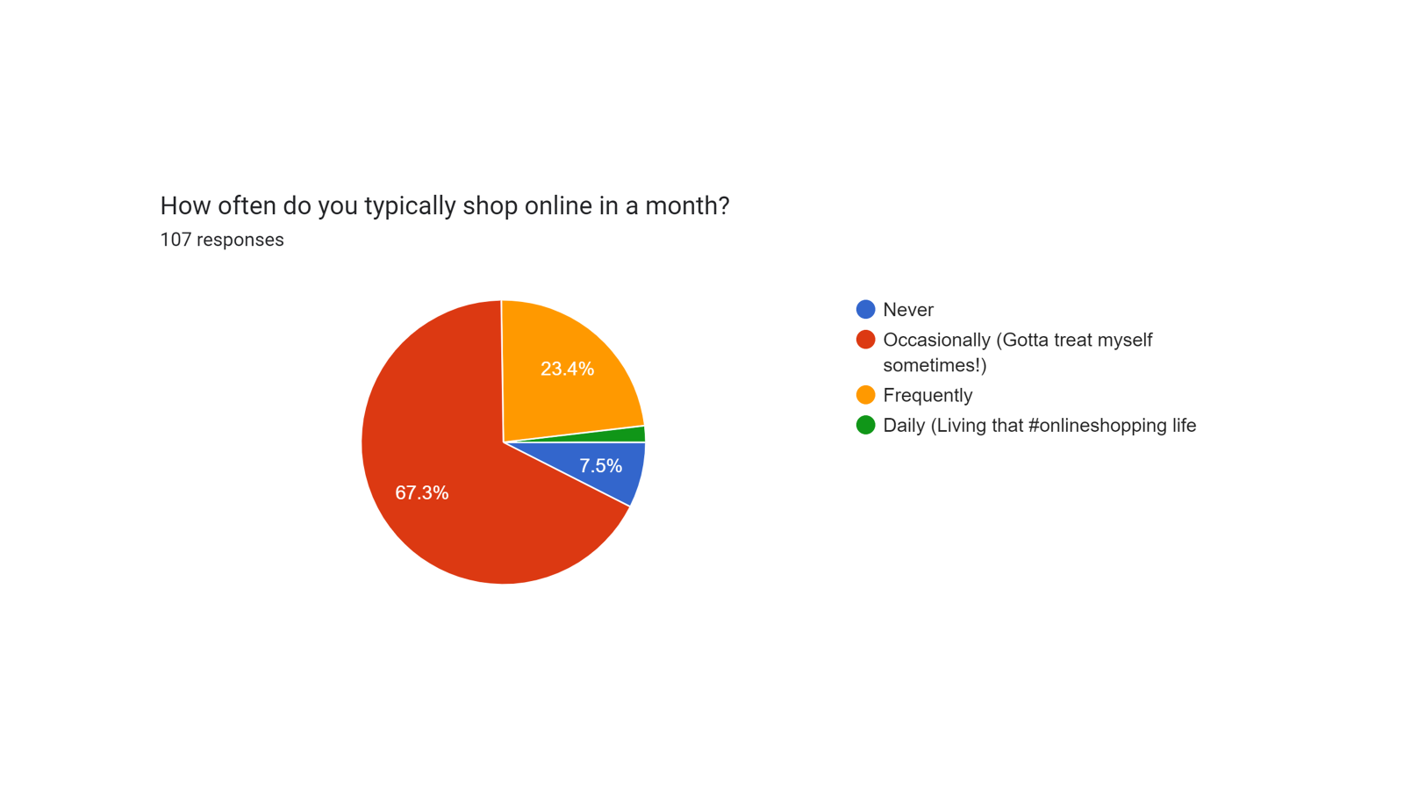

**Interpretation:**

Online shopping appears to be a prevalent option for a sizable portion (around a quarter) of the respondents. There's a possibility that many respondents (potentially reflected in the "occasional" category) integrate both online and in-store shopping into their habits.

1. **Abiding Impact of Offline Stores :**

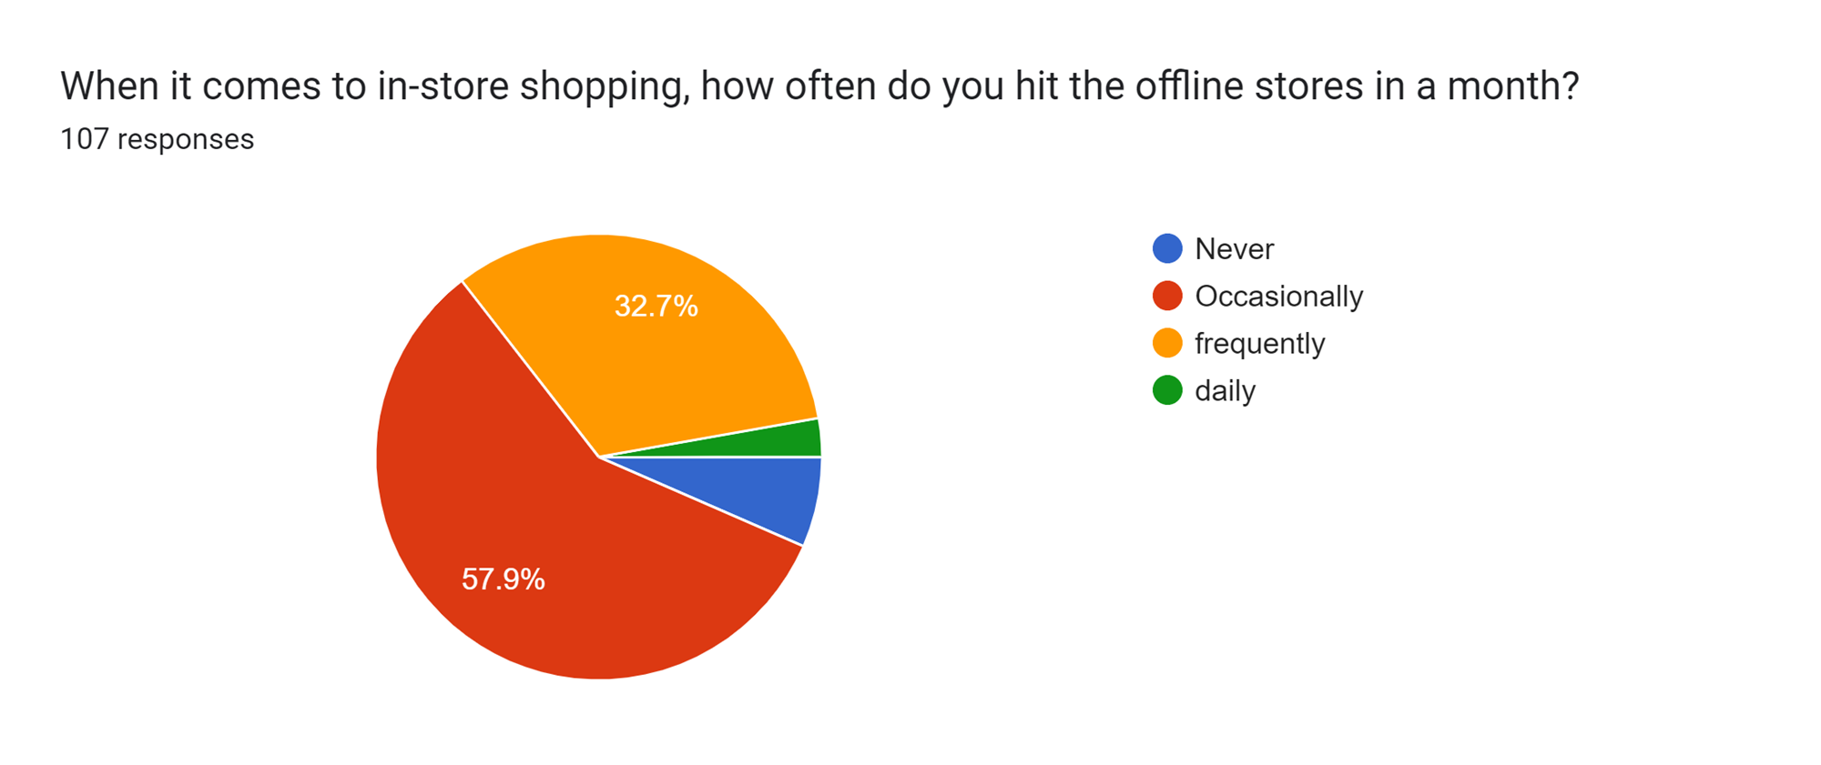

**Interpretation:**

While 57.9 % still occasionally go to the offline stores this answers the ambiguity of the previous poll that majority of the portion of the responses is that audience which is neutral to both online and offline shopping implying that people are still forming decisions as to trust which of the two more

1. **Understanding online business:**

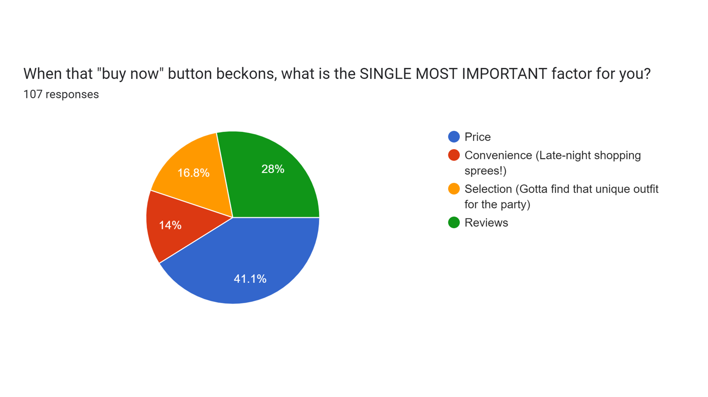**Interpretation:**

In understanding the market strategies in case of the online market we find that the consumer is prominently affected by the price and secondly trusting the product through the word spread through the reviews while convenience and uniqueness might not be the ideal reason for many due to the location of the survey being held , as the responses claim most of the requirements to be present in the close proximity ,

Here we find price taking the lead as the consumer gets the full privilege of comparing different vendors and get the best utilization of his money.

1. **Extent to which the online strategies resonate with the target audience:**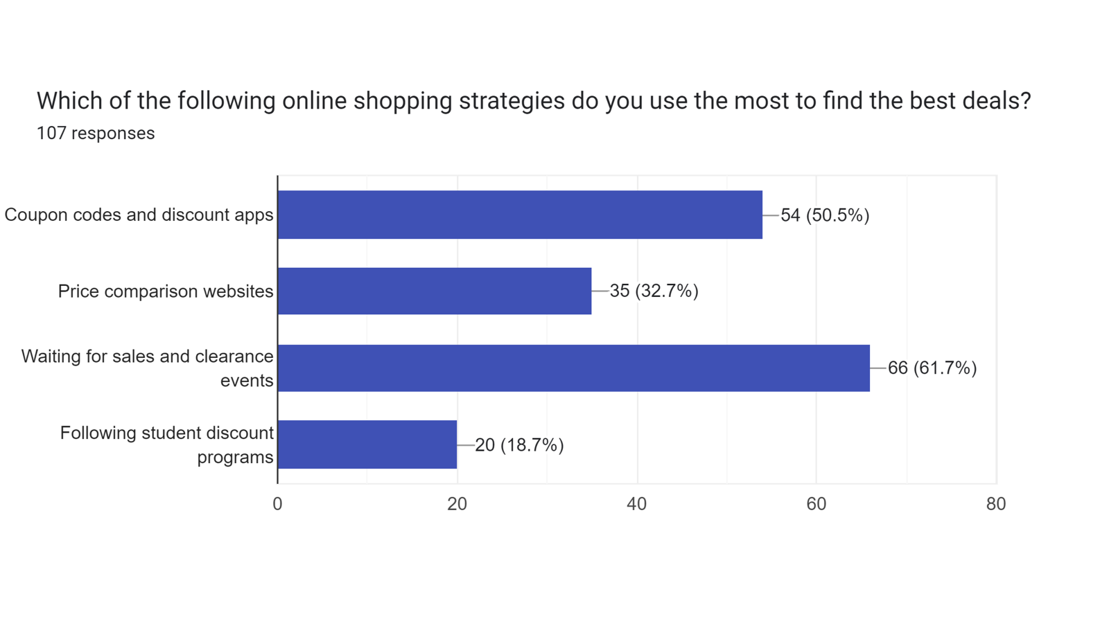

**Interpretation:**

Price remaining the leading factor impacting the buyers online , as a result to which the clearance sale gives the users the most of the benefits and give them the satisfaction of not only saving money but also fuel, time energy and such other resources , making the online market able to manipulate the consumer and make them plan and strategize their savings to be spent during a particular part of the year

1. **Reason for the sustained motivation of the offline buyers:**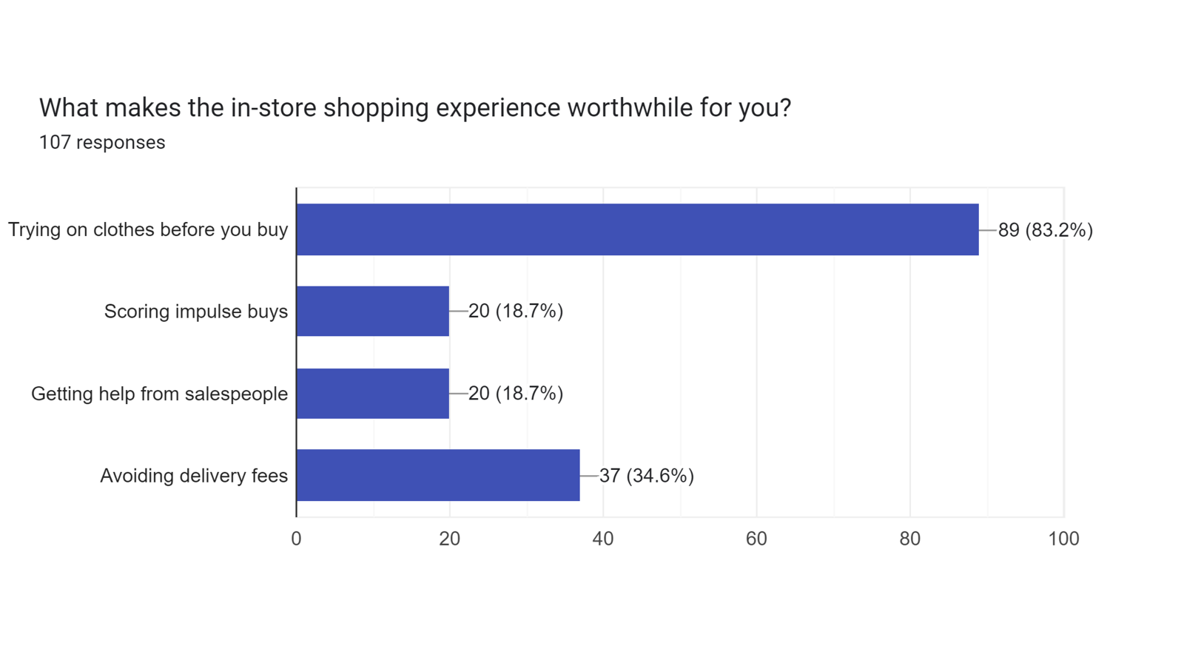

**Interpretation:**

While the market trends give space to the online retailers the main trust still remains with the physical presence of the product than the fancy online reviews , the perks of convenience and time saving property consumers still feel the importance of money more than the physical resources

1. **Rift between online and offline:**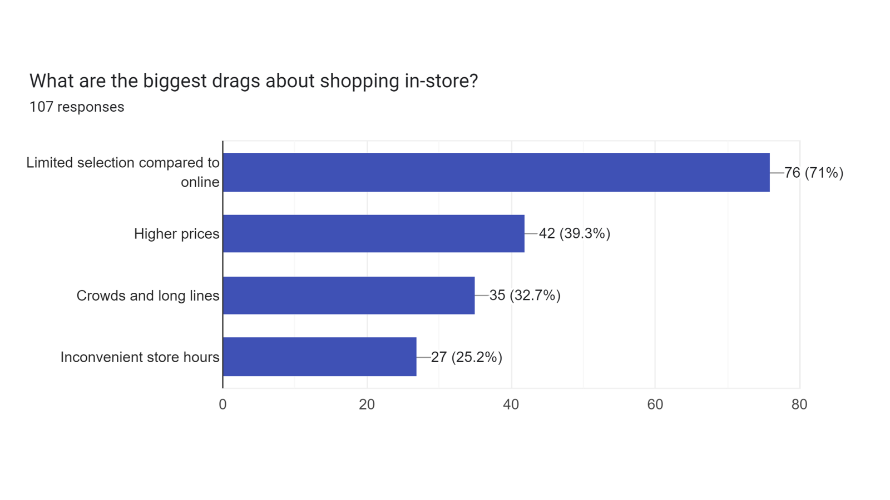

**Interpretation:** At the question of more facilities and availability, online stores prove to have a better edge over the in-store retailers as the in online the user is provided greater variety of choices and the “consumer is king” policy is still maintained

1. **Student centric analysis:**

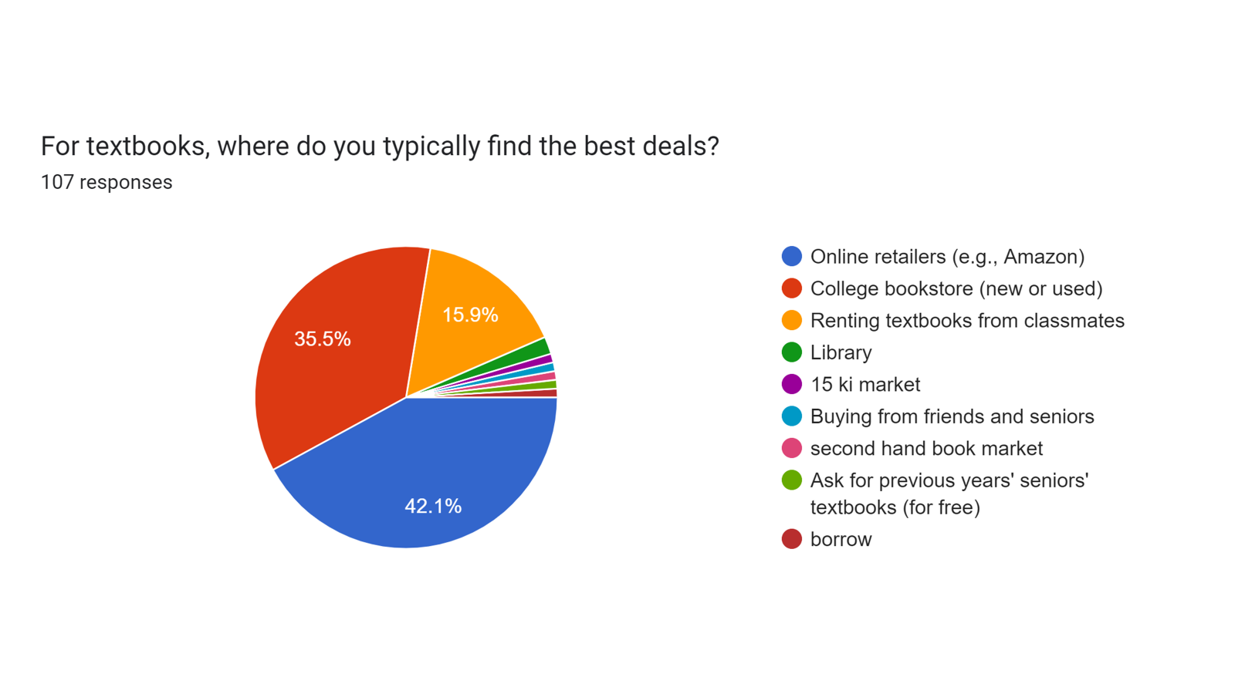

**Interpretation:**

As the demography of the survey was found to be majorly between 18-24 yr the response was collected from the students asking their opinion on purchase of books , while there is a close cut but online market emerges to be a bit more popular due to the time and mobility constraint. The online market however having the popularity due to a better access of second hand books indicating the areas of improvement in the online strategies

1. **Student Centric Survey:**

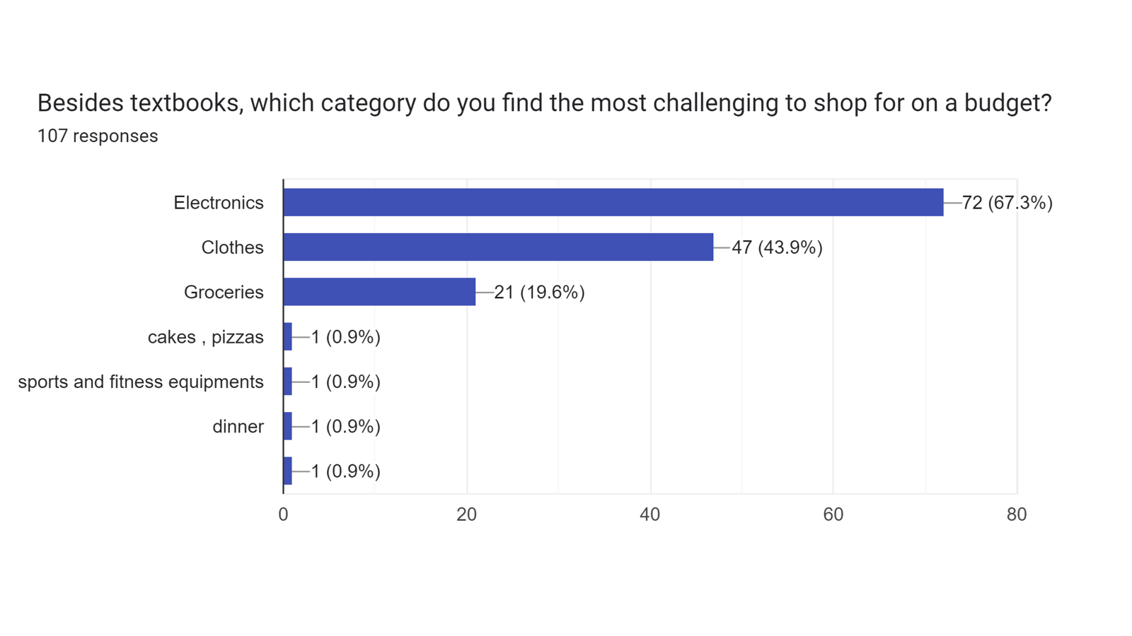

**Interpretation:**

Highlighting the perks of online market and the area of the online market which attracts the audience the most here being electronics more prominently as the talk was raised amongst engineering students , rest showing the craze of fashion and the supply to the necessities

1. **Demography analysis:**

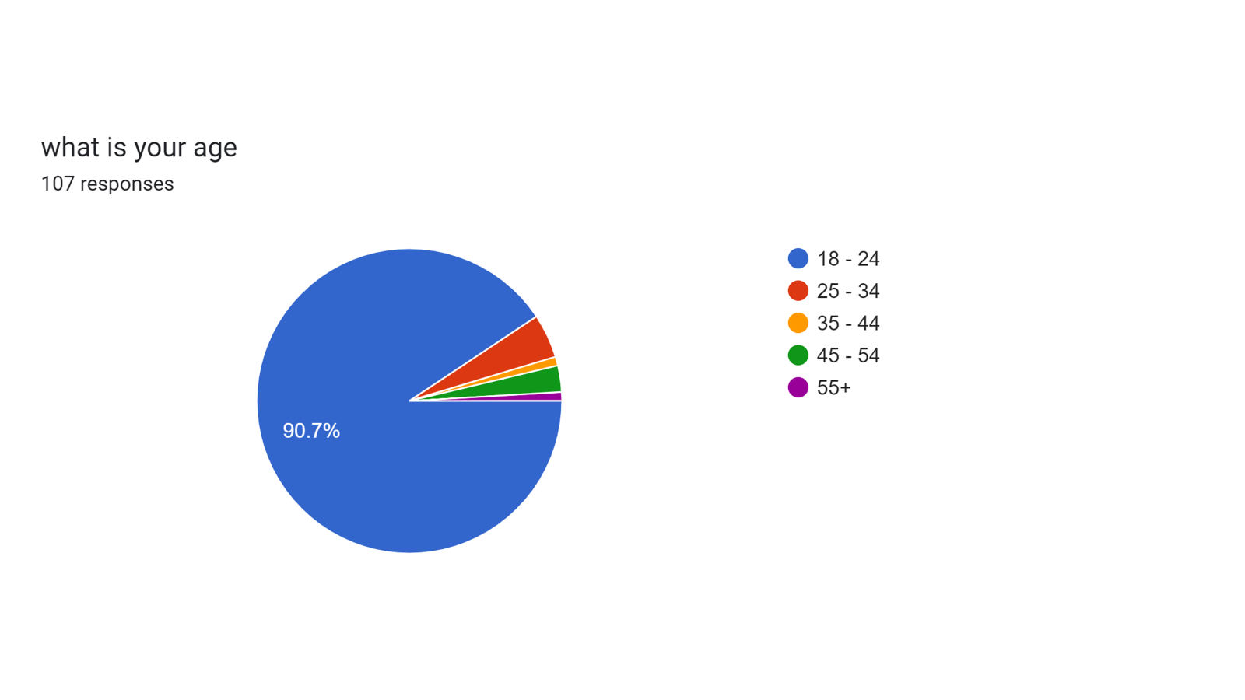

**Interpretation:**

Even though the diversity of the age groups had been covered by the survey , however the main audience still remains to be the students and the people who recently started earning , focussing on the sector which is new to the concept of money and independent monetary exchange increasing the willingness to part from the money and explore the markets

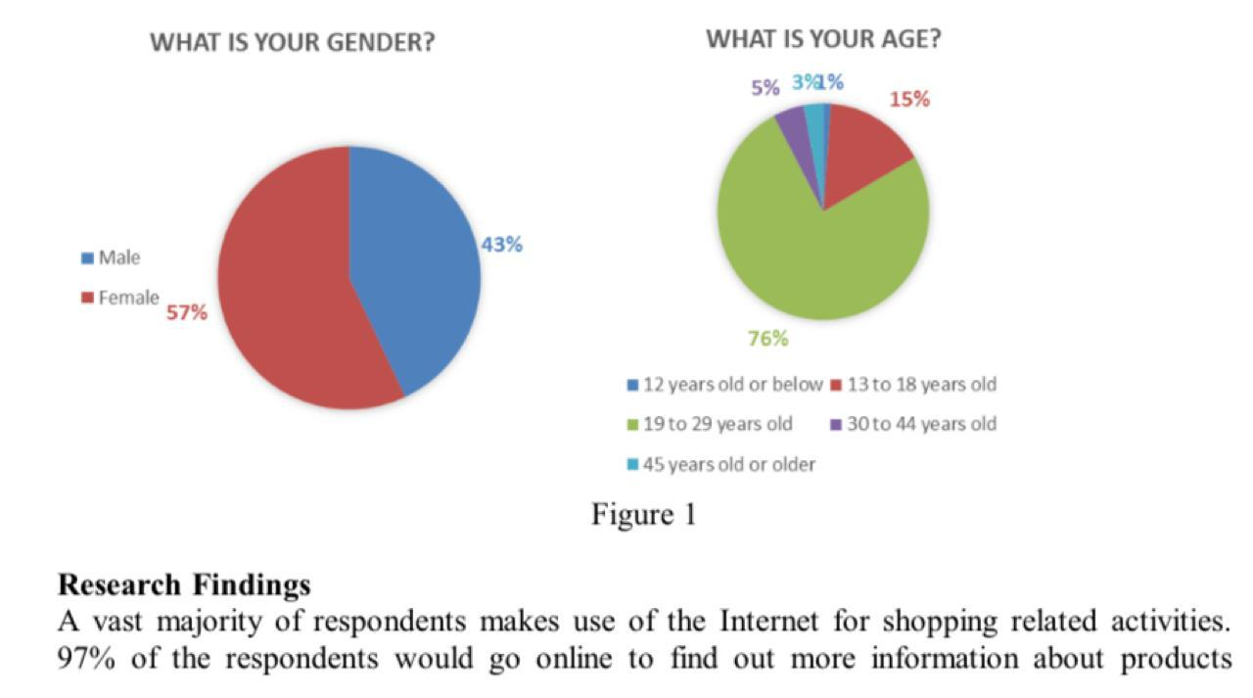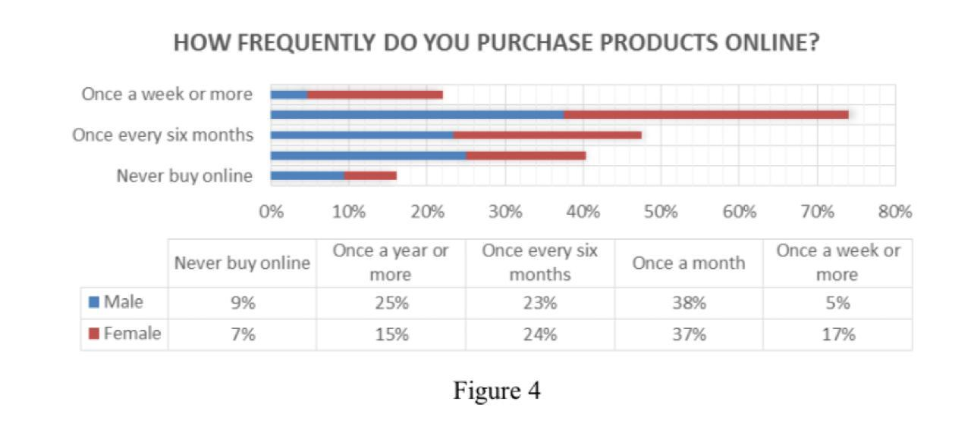

**Findings and Recommendations**

**1. Consumer Habits:** The hype of online shopping is spread over more than a quarter of the responses. However, there are those who occasionally mix it up by engaging in both in-store and online shopping.

**2. Preference for offline stores:** Due to the facilities including staff services and physical check and satisfaction of the customer, offline stores still hold their prestige, along with the perk of avoiding delivery fee.

**3. Factors Influencing Purchasing Decisions:** Price is the main concern of the major chunk of the people when it comes to buying things however some willingly agree to pay more for convenience.

**4. Inadequately Stocked Shops:** Out of stock!! Is a label that would easily annoy the consumer which draws the attention of the online retailer.

**5. Gadgets Costing More Than We Can Afford:** Most people among us suffer whenever they attempt to purchase the latest gadgets on their budgets

**6. Demography:** Students being the majority of the demography, give us a better highlight of the areas of the online marketplace being frequently visited by youngsters, also showing their preferences for both online and offline due to respective reasons.

**Conclusion**

In conclusion, the latest tendencies of consumer behavior in the digital age are looking to reflect dynamism among evolving preferences, technological advancements, and changing retail dynamics. While online retail gains momentum, offline stores remain relevant, particularly for experiences that benefit from physical interaction.

The underscores that there is an urgent need for retailers to take up an omni-channel approach, seamlessly integrating online and offline channels to provide a cohesive shopping experience. The highest- ranking strategies will be those that guarantee meeting the diverse needs and wants of the modern shopper: competitive pricing , convenience , and personalized experiences.

Moreover , the study also articulates the importance of marketing efforts, which are targeted in nature and have to respond continuously with adaptation to shifting consumer behavior and market trends. It means that the retailer will be successful if he focuses on customer preferences, innovates, and develops good relations with his customers.

In the end, our investigation into consumer behavior serves as a reminder of the significant influence that digital transformation has had on the retail sector and the necessity for retailers to develop and adapt in order to satisfy the expectations of the discriminating customers of today. As we navigate the ever-changing landscape of retail, the key lies in embracing change, staying agile, and putting the customer at the heart of every decision.

**Bibliography:**

**REVIEW OF LITERATURE:**

* [**https://www.researchgate.net/publication/335680904_Untact_a_new_customer_service_strategy_in_the_digital_age**](https://www.researchgate.net/publication/335680904_Untact_a_new_customer_service_strategy_in_the_digital_age)
* [**https://www.researchgate.net/publication/378163671_How_Information_Technology_IT_Is_Shaping_Consumer_Behavior_in_the_Digital_Age_A_Systematic_Review_and_Future_Research_Directions**](https://www.researchgate.net/publication/378163671_How_Information_Technology_IT_Is_Shaping_Consumer_Behavior_in_the_Digital_Age_A_Systematic_Review_and_Future_Research_Directions)
* [**https://www.researchgate.net/publication/334942312_Online_Shopping_vs_Offline_Shopping_A_Comparative_Study**](https://www.researchgate.net/publication/334942312_Online_Shopping_vs_Offline_Shopping_A_Comparative_Study)
* [**http://www.gbmrjournal.com/pdf/vol.%207%20no.%201/V7N1-4-Sam%20and%20Sharma.pdf**](http://www.gbmrjournal.com/pdf/vol.%207%20no.%201/V7N1-4-Sam%20and%20Sharma.pdf)
* [**https://search.brave.com/search?q=eScholarship+UC+item+5z75n416.pdf&source=desktop**](https://search.brave.com/search?q=eScholarship+UC+item+5z75n416.pdf&source=desktop)
* [**https://link.springer.com/article/10.1057/s41270-020-00084-6**](https://link.springer.com/article/10.1057/s41270-020-00084-6)
* [**https://link.springer.com/article/10.1057/s41270-020-00084-6**](https://link.springer.com/article/10.1057/s41270-020-00084-6)
* [**https://www.mdpi.com/2071-1050/16/4/1556**](https://www.mdpi.com/2071-1050/16/4/1556)
* [**https://www.sciencedirect.com/science/article/abs/pii/S0160791X24000885**](https://www.sciencedirect.com/science/article/abs/pii/S0160791X24000885)
* [**https://www.theseus.fi/handle/10024/813649**](https://www.theseus.fi/handle/10024/813649)
* [**https://www.sciencedirect.com/science/article/pii/S0925527324000124**](https://www.sciencedirect.com/science/article/pii/S0925527324000124)
* [**https://www.sciencedirect.com/science/article/abs/pii/S0167624509000511**](https://www.sciencedirect.com/science/article/abs/pii/S0167624509000511)